**Cura - HMS**

Mr. Sai Teja Koribilli

Department of Computer Science, Pace University, New York, USA

[sk30386n@pace.edu](mailto:sk30386n@pace.edu)

Ms. Mounika Thalla

Department of Computer Science

Pace University, New York, USA

[mt29944n@pace.edu](mailto:mt29944n@pace.edu)

Mr. Nikhil Kesireddy

Department of Computer Science

Pace University, New York, USA

[sk65032n@pace.edu](mailto:sk65032n@pace.edu)

Mr. Kuldeep Raj Kaluvala

Department of Computer Science

Pace University, NewYork, USA

[kk63804@pace.edu](mailto:kk63804@pace.edu)

Ms. Bindu Valisetti

Department of Computer Science

Pace University, New York, USA

[bv91897n@pace.edu](mailto:%20bv91897n@pace.edu)

Mr. Jigar Shah

Department of Computer Science

Pace University, NewYork, USA

[ss97349n@pace.edu](mailto:ss97349n@pace.edu)

Mr. Shivansh Tomar

Department of Computer Science, Pace University, New York, USA

[st37179t@pace.edu](mailto:st37179t@pace.edu)

**Abstract**

Hospitals aren't just about patients and doctors. There are a few more roles in the hospital management process. When we build hospital software, we usually create separate modules for each role. Every module differs by the access level to data and functionality.

**Keywords**: platforms, on-demand, booking services, handymen

1. **INTRODUCTION**

Developed system is a comprehensive, integrated

information system designed to manage the administrative, financial and clinical aspects of a hospital. As an area of medical informatics, the aim of the system is to achieve the best possible support of patient care and administration by electronic data processing. This encompasses paper-based information processing as well as data processing machines. Laboratory information system is a class of software which handles receiving, processing and storing information generated by medical laboratory processes. People generally do not know the procedures in hospitals. They do not know which department they should go to for their specific medical complaints. So, an intelligent system is required to assist them. Patients will initially be registered in the system with a friendly question and answer menu. Once registration is completed, they will select their medical complaints through a software menu. The menu driven software will present the patient with the right department, doctor name, appointment

date and time, possible medication and laboratory tests subject to doctor’s confirmation. Doctors examine the information provided by the patient and confirm the data once they examine the patient.

1. **LITERATURE REVIEW**

A hospital management system (HMS) is a computerized system that allows the hospitals to manage information and records related to patents, hospital operations, processes, workers and other aspects of healthcare [1]. The HMSs are mainly developed to upgrade the quality of information and improve management of healthcare information as well as efficiency of the healthcare workers. As the hospital operates 24/7 and produces a huge amount of information on a daily basis, which is difficult to manage through traditional paperwork. The hospital database management systems were introduced in the 1960s [1]. To smoothen the workflow and manage all records and information related to healthcare aspects properly, it has evolved and continues to evolve with the integrating of existing and new technologies, software and facilities. There are several reasons behind the development of hospital management systems such as to reduce the paperwork, reducing human intervention and errors, reducing staff burden, and managing healthcare information in a better [2]. The HMSs provide various benefits

including reduction of errors, safety and data privacy, speedier process and improved interaction between patients and healthcare staff and boost productivity. According to [2], an integrated hospital information management system is an important subsystem of the hospital management which is used for optimizing the service quality. In similar manner, [3] conducted study to develop and implement a web-based hospital management systems using web technology. In this study, the author has extended an existing hospital management system which is not completely digitized yet and still requires a lot of paperwork. The proposed system has two modules for doctors and patients, providing facilities of appointments schedules, payment, viewing online information, register on hospital website. The whole process of information sharing and processing in these systems is automated through the ID3 algorithm. Also, [4] developed the front end and back-end interfaces of hospital information management systems using PHP, HTML, CSS, MySQL technologies. To test the performance and usability of this system, the author has conducted unit and integration testing, results of which revealed that the developed system is efficient for managing healthcare information. All modules of this system work well and overall, the system resolves the challenges of data redundancy, saves time on retrieving records, billing management issues and drug management. In another study, [5] developed a web application for managing hospital information using various programming languages such as HTML, CSS, C#, and .net framework for front end interface and MS Access database for back-end data management. Hardware requirements for this system were 1GB RAM, HDD min. 40 GB and Dual core processor. On implementing this application, it has been found that it is responsive for both websites and mobile or tablets. This web application is highly efficient, easy to use and saves a lot of time for both doctors and patients. In the current study, a hospital information system named CURA is developed using React Js for frontend, Node Java Script for backend, MongoDB database and Blockchain technologies. This system provides various functionalities such as registration for patients, data storage, generating computerized bills for pharmacy and labs. Users of the system can also check the availability of doctors and patient’s information and stores information about different healthcare aspects.

1. **PROJECT REQUIREMENTS**

Mentioned below are the product requirements for making sure the project runs at optimal performance and fulfills its defined functional requirements.

*A. Software Requirements*

* Browser: Microsoft Edge, Google Chrome
* IDE: Visual Studio
* Design: Adobe Illustrator, Miro Board
* Assets: Adobe Photoshop
* Database: MongoDB
* Version Control: GitHub
* Project Management: GitHub Projects, JIRA
* Documentation: Microsoft Word, PDF Expert, Excel, Google Docs

*B. Hardware Requirements*

* Development  
  Windows PC: For Android, Web Backend development stack
* End User  
  App: Any iOS, Android device to run the app, Any Web Browser

*C. Functional Requirements*

* The end user will be able to view, and book listed services as required.
* End user could schedule the services in the time slots mentioned.
* User could check the previous history of the services utilized.
* User will get notifications and information of the professional on their web application.
* User can provide feedback and rate the service and the professional.
* End user data would be secure, and the app would preserve privacy as much as possible.
* App will include registration and login features.
* App will suggest multiple professionals according to the ratings provided by other users.

*D. Technical Requirements*

* This is a web application and will support any iOS, Android based devices.
* This web application will be developed using AngularJS, GoLang, NodeJS and utilizes MySQL.

1. **SYSTEM DIAGRAM**
2. Entity Relationship Diagram

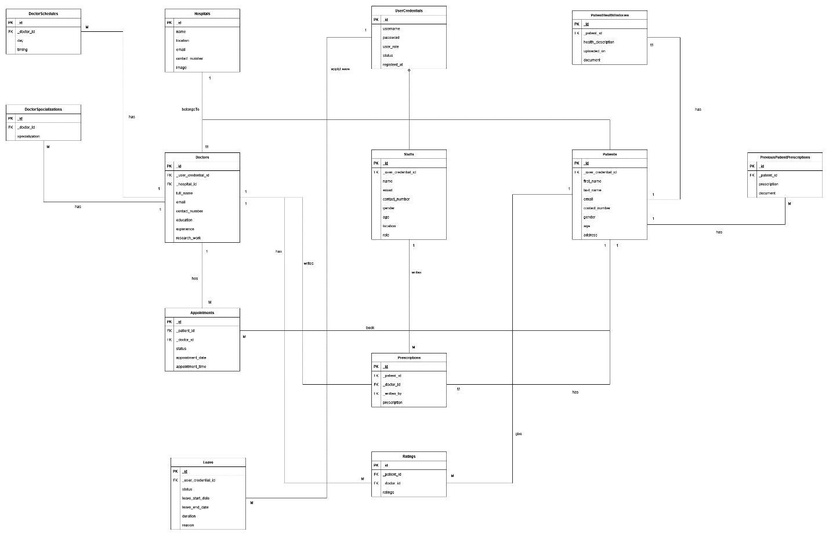 *Figure 4.1 Entity Relationship Diagram*

1. **CONCLUSION**

There are many software packages about Hospital Information Management Systems in the world. This is a developing field, and many researchers are interested in developing new features and applying them to the software. The technique developed here attempts to include the decision 1603 factor in the software. The software decides for the patients where to go and what to do before they see a doctor. This saves a lot of time and helps the doctors to concentrate more on the patients. There are not many intelligent software packages like the developed ones in the market. The software also has a querying system where it can ask various questions to the patient and give them a diagnosis. Many hospital information systems in literature manage inventory of the hospital [4]. This inventory includes patient and staff information, stores and medicines, billing and report generation. This complex application communicates with a background database server and manages all information related to hospital logistics. But our software engages the patients and guides them with a querying mechanism which different and unique in itself. It suggests operational steps to the patients and doctors instead of simple management

1. **SUMMARY**

This software is in modular form and can be adapted to any hospital or clinic. Eventually the developed software will be placed in the internet so that old and disabled patients can also have access to hospitals from the comfort of their homes.

1. **REFERENCE**

[1] Kumaran, S. et al., “A Study of Advanced Hospital Management System,” IOSR Journal of Dental and Medical Sciences (IOSR-JDMS), 16(2), pp. 127–134, February 2017. Available at:https://journals.indexcopernicus.com/api/file/viewByFileId/651165.pdf.

[2]Yulianti, A. and Muhardi, M. “Hospital Management System Analysis in Effort to Improve Service Quality by Using Structured Design Life Cycle Method (A Case Study of Al-Mulk Regional Public Hospital in Sukabumi City)”, 2nd Social and Humaniora Research Symposium (SoRes 2019), pp. 207-209, March 2020, Atlantis Press.

[3] K. Saimanoj, G. Poojitha, K.D. Dixit, and L. Jayannavar,. “Hospital Management System using Web Technology” The Mattingley Publishing Co. Inc., ISSN, vol. 83, pp.0193-4120 May June 2020

[4] Mwase, A., Bwiino, K. and Kyambadde, A,. “An evaluation of a Framework for Supporting Ehealth Service Delivery in a Ugandan rural setting. Online Journal of Nursing Informatics (OJNI), 26(2), 2020.

[5] Anpan, P. et al., “Hospital Management System,” International Research Journal of Engineering and Technology (IRJET), 7(4), p. 1415, April, 2020. Available at: https://www.irjet.net/archives/V7/i4/IRJET-V7I4268.pdf.